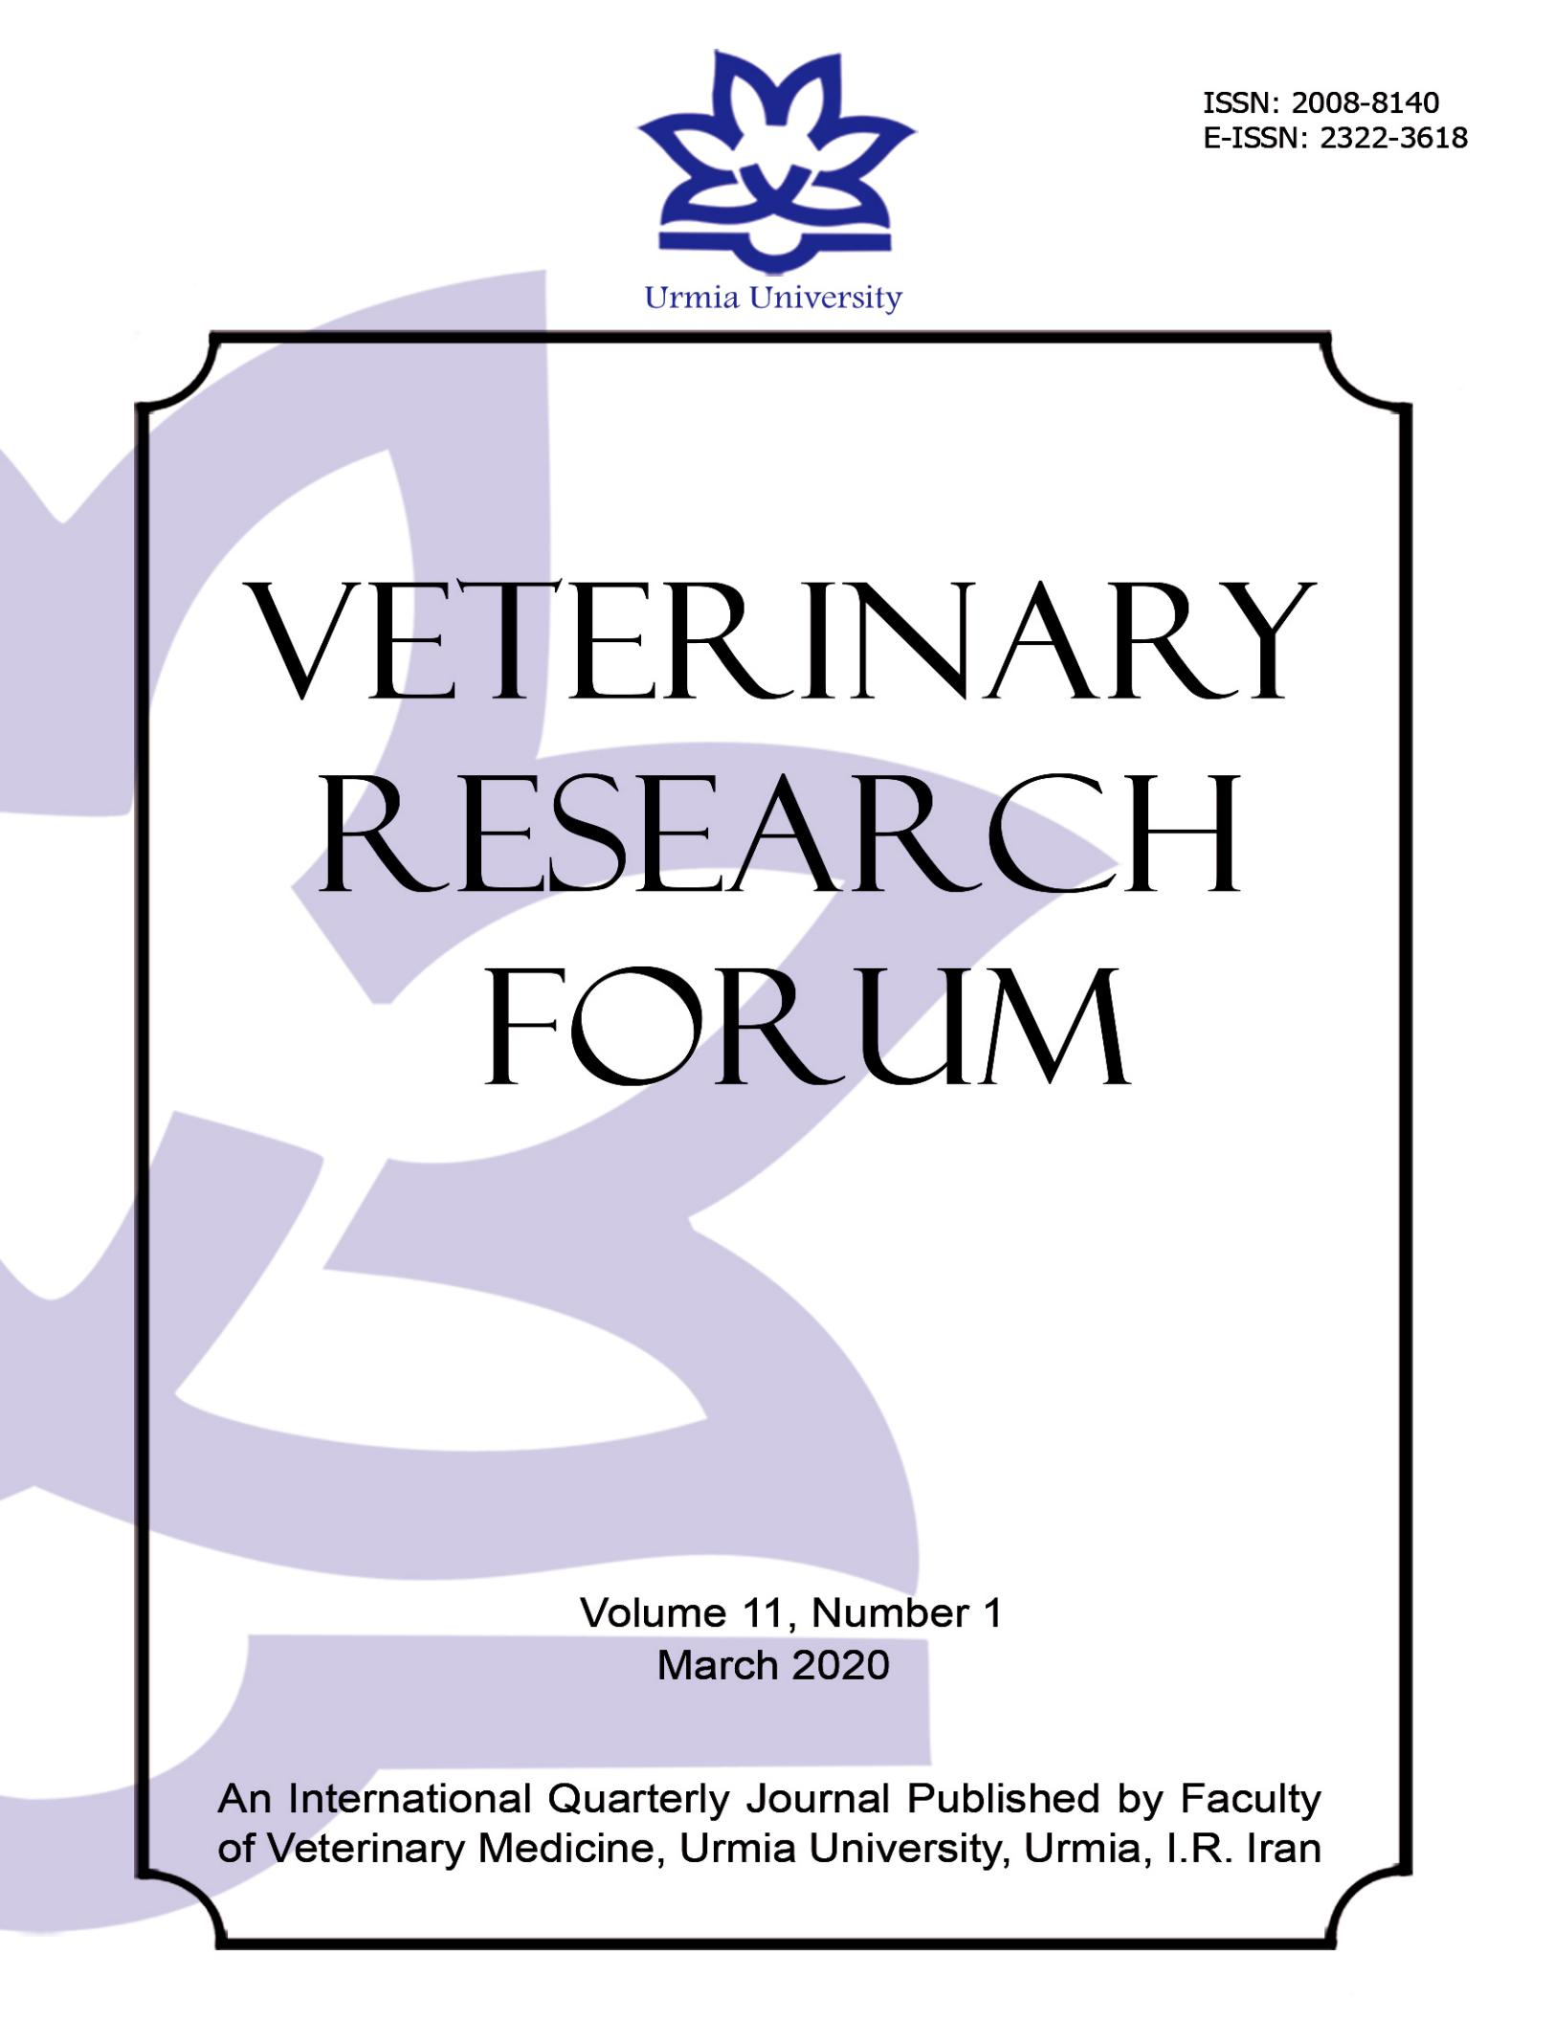

|  |  |  |  |  |  |  |
| --- | --- | --- | --- | --- | --- | --- |
|  |  |  |  |  |  |  |
| **SHORT** |  | ***Veterinary Research Forum. 2020; 11 (1) 83 – 88*** |  |  | **Veterinary** |  |
| **COMMUNICATION** |  | doi: 10.30466/vrf.2019.92045.2228 |  |  | **Research** |  |
|  |  | Journal Homepage: [vrf.iranjournals.ir](http://vrf.iranjournals.ir/) |  |  | **Forum** |  |
|  |  |  |  |  |  |
|  |  |  |  |  |  |
|  |  |  |  |  |  |  |

**Effect of replacement of fish oil with different plant oils in *Oncorhynchus mykiss* broodstocks diets on egg and larval antioxidant defense development**

**Shima Khezrian1, Amir Parviz Salati1*, Naser Agh2, Hossein Pasha-Zanoosi3**

1. *Department of Fisheries, Faculty of Marine Natural Resources, Khorramshahr University of Marine Science and Technology, Khorramshahr, Iran; 2 Department of Biology and Aquaculture, Artemia and Aquaculture Research Institute, Urmia University, Urmia, Iran; 3 Department of Physical Oceanography, Faculty of Marine Science, Khorramshahr University of Marine Science and Technology, Khorramshahr, Iran.*

|  |  |  |
| --- | --- | --- |
| **Article Info** |  | **Abstract** |
|  |  |  |
| **Article history:** |  | This study was undertaken to investigate the effects of feeding rainbow trout |
|  |  | (*Oncorhynchus mykiss)* broodstocks with different ratio of plant oils to evaluate the changes |
| Received: 17 August 2018 |  | in antioxidant defense status in the progenies. In the experimental diets, fish oil was replaced |
| Accepted: 24 April 2019 |  | with different combination of plant oils including corn oil, olive oil, sunflower oil, and coconut |
| Available online: 15 March 2020 |  | oil, to gain different levels of polyunsaturated fatty acids (PUFA) and highly unsaturated fatty |
|  |  | acids (HUFA) in the experimental diets. Fish fed eight weeks with experimental diets before |
| **Keywords:** |  | reproduction. After spawning, samples were taken on days 0, 5, 10, 15, 20, 25, 30 and 35 after |
|  |  | fertilization. The samples were homogenized, centrifuged and the supernatant was removed |
| Antioxidant defense |  | for determination of superoxide dismutase (SOD), catalase (CAT) and glutathione peroxidase |
| Diet |  | (GPX) activity and malondialdehyde (MDA) content. Results showed that SOD activity was |
| Larvae |  | significantly increased from the first sampling to day 35 in all treatment groups. The CAT |
| Plant oil |  | activity showed a downward trend, as the highest CAT activity was observed in the eggs |
| Rainbow trout |  | immediately after fertilization. The GPX activity declined until day five and then showed an |
|  |  | increasing trend. The MDA content did not show significant changes in different groups and |
|  |  | at different sampling times. The antioxidant enzymes activity was significantly influenced by |
|  |  | the dietary PUFA level in the experimental groups but no change in MDA content was |
|  |  | recorded, suggesting that the different percentages of fish oil replacement used in this study |
|  |  | could not result in oxidative stress in early life stages of *O. mykiss*. |
|  |  | **© 2020 Urmia University. All rights reserved.** |
|  |  |  |

**Introduction**

One of the most important aspects of aquaculture is the improvement of fertilized egg quality, which increase the survival and subsequently the growth rate. Broodstocks nutrition affects the reproduction and egg quality of fish. The importance of dietary lipids in the reproductive processes has been reported for several fish species.1 The role of n-3 series fatty acids in sexual maturation and reproductive performance of teleost fish has been reported.2 Sperm and egg quality of fish are affected by dietary fatty acid composition.3,4

The limited availability of fish oil sources has led to plant oils being used in the commercial fish diet,5 thus the other sources of oil have been considered. Plant oils have been successfully used in diets of rainbow trout without

**\*Correspondence:**

impairing fish growth performance.6 In Japanese sea bass, (*Lateolabrax japonicas*) the optimal growth did not achieve by plant oils, but fish health status was remained normal.7 Fatty acids composition of fish oil and vegetable oils are completely different. The fatty acid composition of food is considered to have a very important role in the oxidant-antioxidant equilibrium.8 For example, the polyunsaturated fatty acids (PUFAs) are causative agents in oxidative stress, and also protective agents in the antioxidant defense against stress. The PUFA are susceptible to oxidation and targets for oxygen radicals, which the resultant could be toxic to the cells.9

The production of reactive oxygen species (ROS) induces oxidative stress and could damage cell membranes, inactivate the enzymes, damage the genetic material and the other vital cell components. Therefore, effective anti-

Amir Parviz Salati. DVM, DVSc

Department of Fisheries, Faculty of Marine Natural Resources, Khorramshahr University of Marine Science and Technology, Khorramshahr, Iran **E-mail:** apsalati@kmsu.ac.ir

This work is licensed under a [Creative Commons Attribution-NonCommercial 4.0 International License](http://creativecommons.org/licenses/by-nc/4.0/) which allows users to read, copy, distribute and make derivative works for non-commercial purposes from the material, as long as the author of the original work is cited properly.



*84* ***S. Khezrian et al. Veterinary Research Forum. 2020; 11 (1) 83 - 88***

oxidant systems are essential to maintain health in fish.10 The knowledge of the activity of antioxidant enzymes and of the oxidative state can be the key to understanding the mechanisms involved in the ontogenic development of fish and thus their offspring and survival in farming.11 Few works have studied the oxidative state of fish in their early life stages.11-14 The study of catalase (CAT), superoxide dismutase (SOD) and glutathione peroxidase (GPX) as main antioxidant enzymes during embryogenesis in fish is vital to understand the protection mechanisms against ROS and xenobiotics during the early life stages of organisms as fish in their early life stages are especially vulnerable to changes associated to environmental stress such as temperature, oxygen deficiency and pollution.15

In several studies, the effects of replacement of fish oil with plant oils on antioxidant defense had been evaluated.5,10,16,17 It was showed that the broodstocks diet could affect the development of progenies,3 thus the aim of this work was to examine the antioxidant enzymes (SOD, CAT, and GPX) activities and lipid peroxidation during early stages of development of *O. mykiss* offspring’s collected from broodstocks fed with various levels of plant oils in the diet.

**Materials and Methods**

**Experimental design.** For preparing experimentaldiets, fish oil as the source of lipids in the control diet was replaced with a combination of different plant oils (Fish oil, Canola oil, Linseed oil, Corn oil, Olive oil, Sunflower oil, and Coconut oil) to decrease the HUFA levels but increase the PUFA content (Table 1). The experimental diets contained four levels of PUFA including 13.98%, 21.49%. 25.75% and 30.15% of the total fatty acids. Other fatty acids were balanced in the experimental diets. All ingredients were thoroughly mixed with distilled water (300 mL kg-1 dry ingredients mixture), and 4-5 mm pellets were prepared. The pellets were dried at room temperature for 24 hr and broken into desirable particle sizes. All diets were stored at – 20.00 ˚C until used for in the experiment.

Seventy-two mature female rainbow trout fish, mean weight 566.00 ± 25.00 g were randomly allocated into 12 concrete 10 m3 tanks (n = 6 each tank) at the Artemia and Aquaculture Research Institute, Urmia University, Urmia, Iran. The experiment was performed in triplicate (three tanks were randomly assigned to one of four treatment groups including the control group receiving diet 1, group 1, 2 and 3 receiving diets 2, 3, and 4 respectively). Fish were fed experimental diets two times daily (8:00 AM and 4:00 PM) for eight weeks. The water quality parameters were monitored daily during the experiment period. Photoperiod was 12 hr light and 12 hr dark, temperature 10.20 ˚C; dissolved oxygen 7.80 mg L−1 and pH 7.5.

No critical values were recorded for NH3 concentration. Seven male fish was used in each group. Males were kept in similar condition with females and fed by a basal diet.

After feeding fish for eight weeks, eggs were obtained from three female fish in each group, and the eggs were mixed and divided into batches (10.00 g eggs). Then, 10 mL of D532 buffer (20.00 mM Tris, 30.00 mM glycine, 125.00 mM NaCl, pH= 9.00) was added to the eggs in a 100-mL plastic cup. The milt samples were immediately added, and the gametes were swirled. After 2 min, the eggs were rinsed with hatchery water, incubated for 5 min to water-harden the eggs, and then incubated in upwelling incubation trays. Triplicate batches of eggs from each group were incubated in separate trays. Egg and larvae samples were sampled with a net washed in distilled water and frozen immediately in liquid nitrogen. The samples were taken on days 0, 5, 10, 15, 20, 25, 30 and 35 after fertilization (3.00 g at each stage). All samples were put in liquid nitrogen and kept at – 80 ˚C until they analyzed.

**Biochemical analysis.** Samples (1.00 g × threereplicates) were homogenized in ice-cold buffer (100 mM Tris–HCl, 0.10 mM EDTA and 0.10% Triton X-100 (v/v), pH 7.80) at a ratio of 1:4 (w/v). Homogenates were centrifuged at 16,000 *g* for 30min in a Centrikon H-401 centrifuge. After centrifugation, the supernatant was collected and frozen at – 80 ˚C until analysis.11 The activity of SOD enzyme was evaluated using SOD detection kit (Randox, Crumlin, UK) according to the manufacturer’s instructions and expressed as unit per milligram of protein (U mg-1 protein). Briefly, SOD activity was measured at 550 nm as the degree of inhibition of cytochrome C reduction by O2-Generated in the xanthine oxidase/hypoxanthine system. The activity of GPX was evaluated using GPX detection kit (Randox) according to the manufacturer’s instructions. The GPX activity was expressed as U mg-1 protein. GPX catalyzes the oxidation of glutathione (GSH) by cumene hydroperoxide. In the presence of glutathione reductase (GR) and NADPH, the oxidized glutathione (GSSG) is immediately converted into the reduced form with concomitant oxidation of NADPH to NADP+. The decrease in the absorbance was measured spectrophotometrically against the blank at 340 nm. The CAT activity was measured according to the method described by Aebi.18 Briefly, the reaction was initiated by the addition of hydrogen peroxide to the sample and the level of enzyme activity was quantitated according to the decrease in absorbance at 240 nm against a blank contains phosphate buffer instead of substrate. Malondialdehyde (MDA) was measured as described by Buege and Aust.19 Briefly, one volume of supernatant was mixed with two volumes of a stock solution of 15.00% w/v trichloroacetic acid, 0.37% w/v thiobarbituric acid and 0.25 M HCl thoroughly. The solution heated for 15 min in a boiling water bath.

|  |  |
| --- | --- |
| ***S. Khezrian et al. Veterinary Research Forum. 2020; 11 (1) 83 - 88*** | *85* |

**Table 1.** Source of oil and fatty acid composition of the experimental diets (%).

|  |  |  |  |  |
| --- | --- | --- | --- | --- |
| **Sources** | **Diet 1** | **Diet 2** | **Diet 3** | **Diet 4** |
|  |  |  |  |  |
| **Fish oil** | 80.00 | 40.00 | 20.00 | 0.00 |
| **Canola oil** | 0.00 | 22.50 | 25.00 | 30.00 |
| **Linseed oil** | 2.00 | 3.00 | 4.75 | 6.30 |
| **Corn oil** | 18.00 | 0.00 | 0.00 | 0.00 |
| **Olive oil** | 0.00 | 0.00 | 4.00 | 5.50 |
| **Sunflower oil** | 0.00 | 19.00 | 23.75 | 28.20 |
| **Coconut oil** | 0.00 | 15.50 | 22.50 | 30.00 |
| ***Composition*** | **Diet 1** | **Diet 2** | **Diet 3** | **Diet 4** |
|  |  |  |  |  |
| **SFA** | 23.70 | 24.08 | 23.81 | 23.73 |
| **MUFA** | 41.23 | 41.42 | 41.46 | 41.18 |
| **PUFA** | 13.98 | 21.49 | 25.75 | 30.15 |
| **HUFA** | 15.90 | 7.95 | 3.98 | 0.00 |
| **HUFA/PUFA** | 1.14 | 0.37 | 0.15 | 0.00 |
| **HUFA/MUFA** | 0.39 | 0.19 | 0.10 | 0.00 |
| **HUFA/SFA** | 0.67 | 0.33 | 0.17 | 0.00 |



SFA: Saturated fatty acids, MUFA: Monounsaturated fatty acids, PUFA: Polyunsaturated fatty acids, HUFA: Highly unsaturated fatty acids.

After cooling, the precipitate was removed by centrifugation at 1000 *g* for 10 min and the absorbance of the clear supernatant determined at 535 nm. The protein content of the supernatants for enzyme analysis was determined using Lowry colorimetric method using bovine albumin as the standard.20

**Statistical analysis.** Statistical analysis was performedusing SPSS Software (version 16.0; IBM Corp., Armonk, USA). The results were presented as means ± standard error. Data were tested for normality using Shapiro-wilk test. Analysis of variance (ANOVA) was employed to reveal significant differences in measured variables among experimental groups in each sampling time. Duncan multiple comparison test was used to discriminate significant differences between the treatments.

**Results**

The activity of various enzymes of the antioxidant system in the examined fish showed different patterns during the period of study. The SOD activity showed an increasing pattern in all experimental groups (Fig. 1).

The lowest value for SOD was recorded on day 0 while its highest value was recorded on day 35 in all groups. The SOD activity was significantly affected by dietary oil source and PUFA content, as SOD activity was lower in the group fed by 30.15% PUFA and no HUFA than the other groups. GPX activity was low in all groups and remained relatively constant until day 5, then the activity markedly increased by approximately two-fold and this was continued as the highest value was recorded on day 35 (Fig. 1A). The activity of CAT decreased significantly over the period of the study with the largest decrease occurred over days 0– 5 (*p* < 0.05), (Fig. 1B). This change was effected by the fatty acid content of the diet as the highest decrease was seen in the control group which their broodstocks were fed by basal diet, while in the groups that HUFA/PUFA ratio was

0.37 the least difference was recorded (*p* < 0.05). Also, the final activity of CAT was significantly different in the experimental groups. The highest value of CAT was seen on day 35, in the group that HUFA/PUFA ratio was 0.37 while in the group received only PUFA, the lowest activity of CAT was recorded (*p* < 0.05)*.* In contrast, GPX activity (Fig. 1C) was dependent to oil replacement in broodstocks diet, as in the groups which received lower HUFA/PUFA level it was higher compared to the other groups (*p* < 0.05).

Comparing the levels of MDA showed a similar pattern in all the experimental groups (Fig. 1D). The MDA was increased during days 0-5, then reduced sharply and remained unchanged till day 35. The MDA content was not affected by the dietary fatty acid content as its value did not show significant changes between different groups at each sampling time.

**Discussion**

The characterization of the antioxidant defense system and oxidative status reveals the mechanisms involved in the early development and survival of fish and their progeny in farms. Also, perception of the effects of PUFA on the antioxidant defense helps to prepare proper diet formulations for broodstocks in order to improve the immune system in their early life stages. Only few works have evaluated the development of antioxidant defense system in early life stages of fish.11,12,17 The quantifiable values of antioxidant system enzymes activity was measured in *O. mykiss* eggs prior to hatching, suggesting that the eggs are well protected against peroxidation, despite the high levels of polyunsaturated fatty acids (PUFAs) incorporated in their structure.15 GPX showed little activity in the first days but decreased until day 5 and increased from day 10 till the end of the period of the study. Similar findings have been reported in *O. mykiss*

*86* ***S. Khezrian et al. Veterinary Research Forum. 2020; 11 (1) 83 - 88***

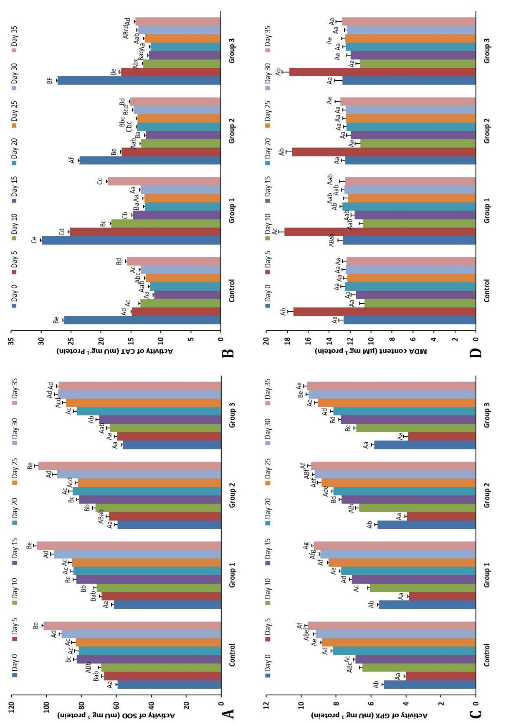

|  |
| --- |
| different sampling times. significant differences among treatments within sampling time and the same lower case letters indicate no significant differences among the same treatment in **C)** glutathione peroxidase (GPX; mU mg-1protein) and **D)** malondialdehyde (MDA) content (µM per mg-1protein) in their progeny. The same capital letters indicate no **Fig. 1.** Effect of different levels of plant oils in broodstocks diets on Activity of A**)** Superoxide dismutase (SOD; mU mg-1protein), **B)** Catalase (CAT; mU mg-1protein), |

|  |  |
| --- | --- |
| ***S. Khezrian et al. Veterinary Research Forum. 2020; 11 (1) 83 - 88*** | *87* |

reared in different stocking density.13 The GPX decreased until day 5, which was similar to the findings reported for Asian seabass, *Lates calcarifer*.14 They reported that GPX activity was high at gastrulation, which may be contributed to the high metabolic activity, after that its activity gradually decreased. In this study, GPX activity was higher in the group which broodstocks fed with a higher PUFA/HUFA level diet than the other groups. In *O.* *mykiss* fed with n-3 PUFA, an increase in blood antioxidantcapacity protection from free radical damage was reported.21 This antioxidant activity could act as a homeostatic mechanism counteracting the increased oxidative stress.

The SOD and CAT are responsible for the inactivation of superoxide and hydrogen peroxide respectively. The SOD, by converting superoxide to hydrogen peroxide, provides a substrate for CAT.21 SOD activity showed an incremental pattern while decreasing pattern was recorded for CAT. Peters and Livingstone and Mourente *et al*. showed that SOD decreased throughout larvaldevelopment from the egg in *S. maximus* and *Dentex* *dentex*, respectively. Increase in SOD activity14and nochanges15 were also reported. CAT activity decreased during the period of this study, while previous reports in different species are controversial. Kalaimani *et al.* (2008) found similar results in Asian seabass. They reported that CAT activity decreased on day 5 till day 25, but CAT activity was increased in *Acipenser naccarii* during early life stages.11 This could be related to the changes in the protein levels during the ontogenic development in different species.22

The increase in antioxidant enzymes activity helped to maintain the MDA content constant in all sampling times, as no significant changes were recorded in experimental groups and control at different times. This situation reflecting no change in accumulation through enhanced antioxidant systems and/or increased excretion rate.10

Our findings showed that *O. mykiss* offspring are protected from the dangers of free radicals as enzymes activities were recorded immediately after fertilization. Different PUFA/HUFA levels added to broodstocks diets had no adverse effects on oxidant-antioxidant equilibrium during the early life stages of the examined fish.

**Acknowledgments**

The authors gratefully acknowledge Urmia University for providing the facilities for undertaking this project and Khorramshahr University of Marine Science and Technology for the financial support of the project.

**Conflict of interest**

Authors declare that they have no conflict of interest.

**References**

1. Watanabe T, Arakawa T, Kitajima C, et al. Effect of nutritional quality of broodstocks diets on reproduction of red sea bream. Bull Jap Soc Sci Fish 1984; 50(3): 495-501.
2. Izquierdo MS, Fernandez-Palacios H, Tacon AGJ. Effect of broodstocks nutrition on reproductive performance of fish. Aquaculture 2001; 197(1-4): 25-42.
3. Lahnsteiner F, Mansour N, McNiven MA, et al. Fatty acids of rainbow trout (*Oncorhynchus mykiss*) semen: composition and effects on sperm functionality. Aquaculture 2009; 298(1-2): 118-124.
4. Vassallo-Agius R, Watanabe T, Yoshizaki G, et al. Quality of eggs and spermatozoa of rainbow trout fed an n-3 essential fatty acid deficient diet and its effects on the lipid and fatty acid components of eggs, semen and livers. Fisheries Sci 2001;67(5): 818-827.
5. Kjaer MA, Aursnes IA, Berge GM, et al. The influence of different dietary oil qualities on growth rate, feed utilization and oxidative stress in Atlantic cod. Aquac Nutr 2014; 20(2): 192-204.
6. Caballero MJ, Obach A, Rosenlund G, et al. Impact of different dietary lipid sources on growth, lipid digestibility, tissue fatty acid composition and histology of rainbow trout, *Oncorhynchus mykiss*. Aquaculture 2002; 214(1-4): 253-271
7. Peng X, Li F, Lin S, et al. Effects of total replacement of fish oil on growth performance, lipid metabolism and antioxidant capacity in tilapia (*Oreochromis niloticus*). Aquac Int 2016; 24(1): 145-156.
8. Kiron V, Puangkaew J, Ishizaka K, et al. Antioxidant status and nonspecific immune responses in rainbow trout (*Oncorhynchus mykiss*) fed two levels of vitamin E along with three lipid sources. Aquaculture 2004; 234(1-4): 361-379.
9. Kiron V, Thawosuwan J, Panigrahi A, et al. Antioxidant and immune defense of rainbow trout (*Oncorhynchus* *mykiss*) offered plant oils differing in fatty acid profilesfrom early stages. Aquac Nutr 2011; 17(2): 636-643.
10. Mourente G, Tocher DR, Diaz E, et al. Relationship between antioxidants, antioxidant enzyme activities and lipid peroxidation products during early development in *Dentax dentax* eggs and larvae. Aquaculture 1999; 179(1-4): 309-324.
11. Díaz ME, Sanz A, Furné M, et al. Antioxidant defences in the first life phases of the sturgeon (*Acipenser naccarii*). Aquaculture 2010; 307(1-2): 123-129.
12. Taghipoor K, Keyvanshokooh S, Salati AP, et al. Effects of triploidy induction on antioxidant defense status in rainbow trout (*Oncorhynchus mykiss*) during early development. Anim Reprod Sci 2016; 171: 108-113.
13. Sharifi S, Salati AP, Asadian P, et al. Alterations to antioxidative enzymes in early life stages of rainbow trout (*Oncorhynchus mykiss*) reared in different

*88* ***S. Khezrian et al. Veterinary Research Forum. 2020; 11 (1) 83 - 88***

densities. J Vet Res 2014; 69(4): 389-395.

1. Kalaimani N, Chakravarthy N, Shanmugham R, et al. Anti-oxidant status in embryonic, post-hatch and larval stages of Asian seabass (*Lates calcarifer*). Fish Physiol Biochem 2008; 34(2): 151-158.
2. Aceto A, Amicarelli F, Sacchetta P, et al. Developmental aspects of detoxifying enzymes in fish (*Salmo iridaeus*). Free Radic Res 1994; 21(5): 285-294.
3. Kutluyer F, Sirkecioğlu AN, Aksakal E, et al. Effect of dietary fish oil replacement with plants oils on growth performance and genes expression in juvenile rainbow trout (*Oncorhynchus mykiss*). Ann Anim Sci 2017; 17(4): 1135-1153.
4. Castro C, Perez-Jimenez A, Coutinho F, et al. Dietary carbohydrate and lipid sources affect differently the oxidative status of European sea bass (*Dicentrarchus*

*labrax*) juveniles. Br J Nutr 2015; 114(10): 1584-1593.

1. Aebi H. Catalase *in vitro*. Methods Enzymol 1984; 105: 121-126.
2. Buege JA, Aust SD. Microsomal lipid peroxidation. Methods Enzymol 1978; 52: 302-310.
3. Lowry OH, Rosebrough NJ, Farr AL, et al. Protein measurement with Folin phenol reagent. J Biol Chem 1951; 193(1): 265-275.
4. Koprucu K, Yonar ME, Ozcan S. Effect of dietary n-3 polyunsaturated fatty acids on antioxidant defense and sperm quality in rainbow trout (*Oncorhynchus mykiss*) under regular stripping conditions. Anim Reprod Sci 2015; 163: 135-143.
5. Peters LD, Livingstone DR. Antioxidant enzyme activities in embryologic and early larval stages of turbot. J Fish Biol 1996; 49(5): 986-997.